T. PRANEETHA
192412588
ECA3102
NANO ELECTRONICS

EXP 1: Simulation of Density of States of Quantum Well Structure with Various Nanometer Thickness.
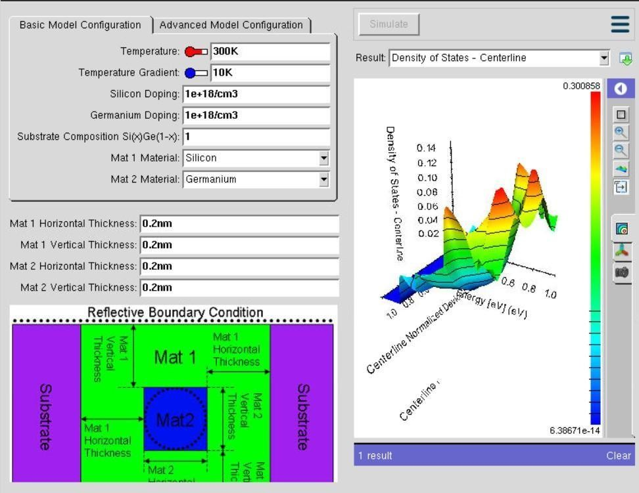
In Experiment 1, the objective was to study how the Density of States (DOS) changes with different quantum well thicknesses. The simulation was performed using the NanoHUB online simulation tool, specifically the Thermoelectric Factor Calculator for Nanocrystalline Composites. The experiment was conducted by selecting a semiconductor material such as Silicon or Germanium and varying the quantum well thickness (for example, 0.5 nm and 0.6 nm) while keeping all other simulation parameters unchanged. The purpose of changing only the thickness was to observe the effect of quantum confinement on the electronic properties of the quantum well. When the thickness is very small, electrons are confined in a narrow region, leading to discrete energy levels and changes in the Density of States. By comparing the DOS
graphs obtained for different thickness values, the experiment demonstrates how and why the

Case Study 1: Simulate the density of states of quantum well of thickness 0.5 nm
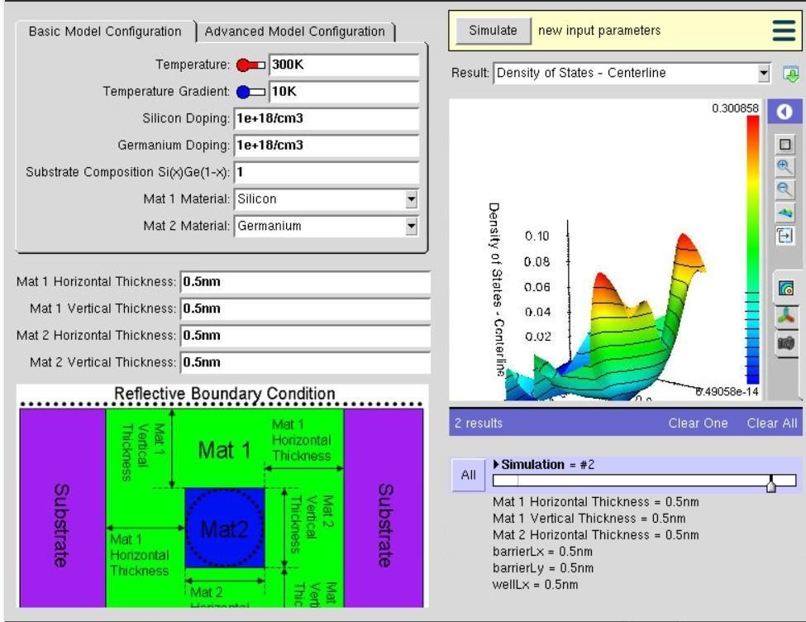

In Case Study 1, the simulation was performed to analyze how a very thin quantum well (0.5 nm) affects the Density of States (DOS). The study was carried out using the NanoHUB online simulation tool, specifically the Thermoelectric Factor Calculator for Nanocrystalline Composites. The quantum well thickness was changed to 0.5 nm while keeping all other parameters unchanged. This thickness was selected because a smaller quantum well produces strong quantum confinement, restricting the movement of electrons and creating widely separated energy subbands. As a result, the Density of States graph changes, demonstrating how reducing the well thickness influences the electronic properties of the material. This case study helps in understanding the effect of strong quantum confinement in nanoscale semiconductor deviice

Case Study 2: Simulate the density of states of quantum well of thickness 0.6 nm
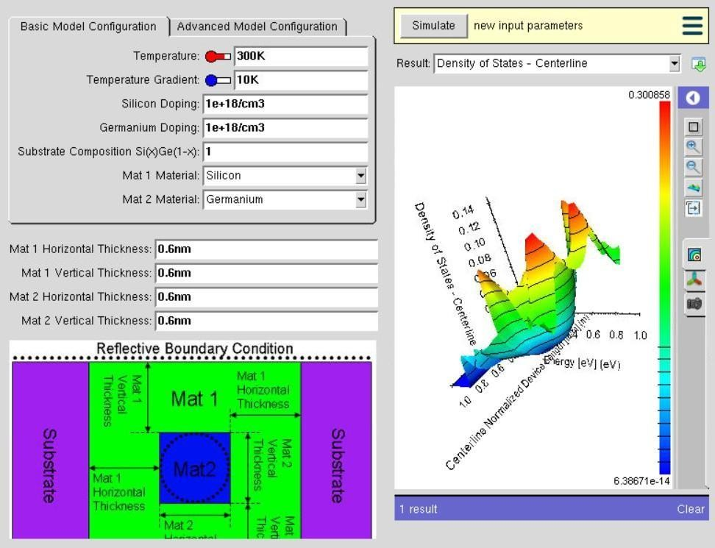

In Case Study 2, the simulation was conducted to study the effect of increasing the quantum well thickness to 0.6 nm on the Density of States (DOS). The simulation was performed using the NanoHUB online simulation tool with the same material and simulation settings as in Case Study 1. The only parameter changed was the quantum well thickness, which was increased from 0.5 nm to 0.6 nm.
Increasing the thickness reduces the quantum confinement effect, allowing electrons to occupy energy levels that are closer together. Consequently, the Density of States graph differs from the previous case, showing the influence of increased thickness on the electronic characteristics of the quantum well. This case study demonstrates how a slight increase in nanometer-scale thickness can significantly affect the electronic behavior of semiconductor quantum well structures.

Conclusion
The simulation shows that the Density of States (DOS) changes with quantum well thickness. Thinner wells have stronger quantum confinement, while thicker wells have reduced confinement, affecting the electronic properties.

